Model definition, assumptions and summary of results

1. Model definition:

We are defining the compartmental model of COVID19 onset and progression as a Markov process. Let $'S'$ be state space and $'Q'$ be the transition rate matrix of the Markov process.

$$S= \left\{\begin{aligned}E, I_{shed}, \\ I_{s,0},I_{s,1}, I_{s,2}, \\ I_{d,0},I_{d,1}, I_{d,2}, \\ H_{0},H_{1}, H_{2}, \\ R, D\end{aligned}\right\}$$

Where,

|  |  |
| --- | --- |
| $$E$$ | Infected cases in latency period |
| $$I_{shed}$$ | Infected cases after latency period and before onset of symptom |
| $$I_{s,i}$$ | Symptomatic cases in ith disease severity state, |
| $$I_{d,i}$$ | Symptomatic cases diagnosed in ith disease severity state |
| $$H_{i}$$ | Hospitalized cases in ith disease severity state |
| $$R$$ | Recovered cases |
| $$D$$ | Death cases |

And,

$$i ∈\{Mild \left(0\right), Moderate \left(1\right), Severe \left(2\right)\}$$

State transition diagram can be shown as presented in ,

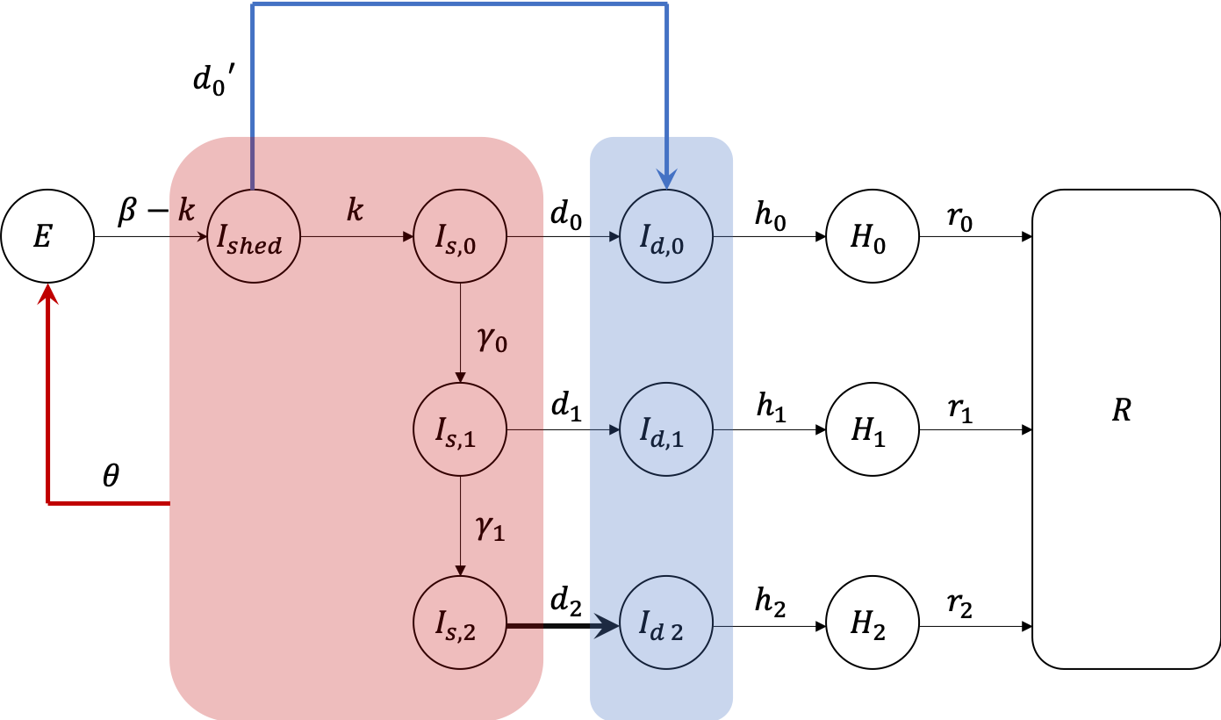

Figure 1: State transition diagram for Markov process

$'Q'$ will be a square matrix of dimension 13 $(\left|S\right|=13)$.

1. Assumptions

|  |  |  |  |
| --- | --- | --- | --- |
|  | Assumption | Additional notes | Supporting literature |
| Reproduction rate |  |  |  |
|  | We assume $R_{0}=3$ and generation of these 3 cases happens in period of 12.5 days |  |  |
| Latency and incubation period |  |  |  |
|  | We assume incubation period of 5.5 days out of which 2.5 days are attributed to latency period. |  |  |
|  | Every case in $E$ compartment will make a transition to $I_{shed}$ compartment (i.e. where each case starts shedding virus) in 3 days (5.5-2.5 days). |  |  |
|  | Every case in $I_{shed}$ compartment will make a transition to mild symptomatic state in 2.5 days. |  |  |
| Progression of disease |  |  |  |
|  | 20% of mild symptomatic will progress to moderate disease state in 7 days. Rest of the 80% will recover in 14 days. |  |  |
|  | 10% of moderate symptomatic will progress to severe disease state in 3 days. Rest 90% will recover in 14 days. |  |  |
|  | No recovery is possible in severe disease state without hospitalization. All severe disease cases (undiagnosed) will transition to death in 7 days. |  |  |
| Diagnosis rates |  |  |  |
|  | We assume, $${d_{2}}/{d_{1}}=1$$ i.e. diagnosis rates of symptomatic moderate and symptomatic severe states are equal. | This can further be addressed by the distribution over cases severity, amongst diagnosed cases. |  |
| Contact tracing |  |  |  |
|  | Currently we assume that $d_{0}=0$, but we add cases to compartment $I_{d,0}$ by contact tracing as follows, $$S=N⋅P(t)\sum_{i}{I_{d,i}(t)}$$ Where, $N$ is number of contacts traced per diagnosed case, $P(t)$ is percentage of positive results out of all the tests performed on a day ‘ $t$’. $P(t)$ is addressed by data from ICMR. Log curve is fitted to the data ($R^{2}=0.95$), $$P\left(t\right)=0.0117\ln\left(t\right)+0.0025$$ |  |  |
| Recovery |  |  |  |
|  | $$r_{s,0}=r_{H,0}=1/14$$ |  |  |
|  | $$r_{s,1}=0.9/14$$ |  |  |
|  | $$r_{H,1}=1/(10.63*2)$$ | Value is 10.63 days in the paper but recovery estimates from model are much higher than data with that value. I multiplied it with 1.5 and 2, latter seems to be a good choice. |  |
|  | $$r_{H,2}=1/(22*2)$$ | The multiplier 2 comes from same reasoning as above. |  |

1. Preliminary results

Figure 2: Calibration model fit for India data

Key observations:

1. We are fitting to active cases (smoother than incident cases) and that is reproduced by model accurately.
2. Recoveries are over estimated.
3. Deaths are over estimated.
4. Diagnosis rate is increasing exponentially, this points to the possibility of symptomatic population being exhausted.
5. Current solution of diagnostic rates is still in plausible range.

|  |  |
| --- | --- |
|  |  |
|  |  |

Model fitting to Punjab data:

Figure 3: Calibration model fir for Punjab data

|  |  |
| --- | --- |
|  |  |
|  |  |